ECOMMERCE MGT

USE CASE DIAGRAM

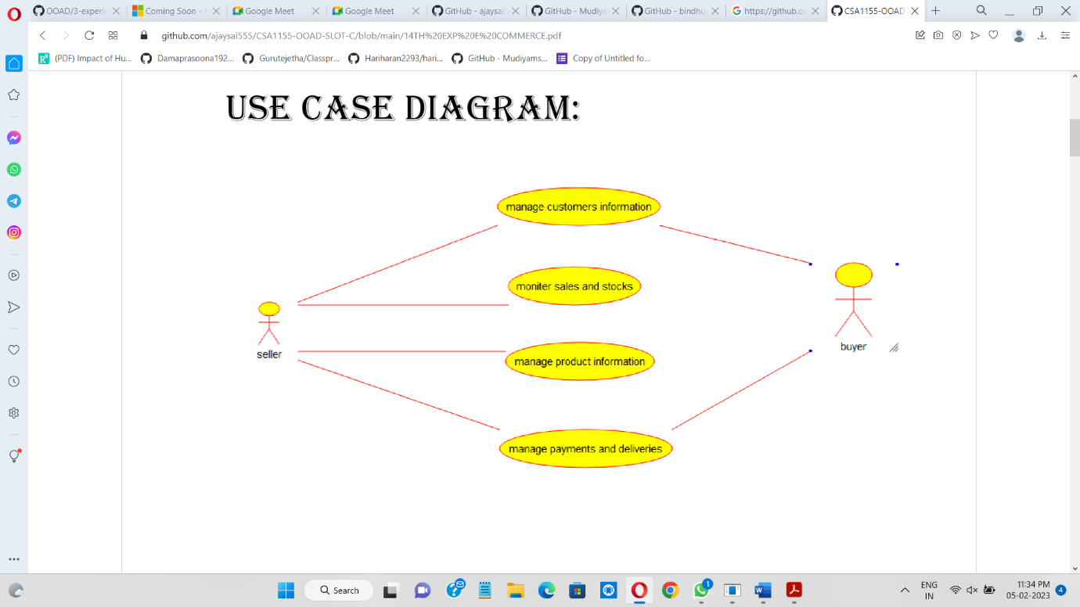

CLASS DIAGRAM

